Giude Lines on How to Capture Learner

Organisation: | FPMSETA
Project name: | Giude Lines on How to Capture Learner

Table of Contents
1. System Access 3
2. General 4
3. Learner 5
4. Capturing Learner Details 6
5. Registration of Programmes against Learners 7
Programme Registrations: Unit Standards 9
Programme Registrations: Qualification 10
Programme Registrations: Skills Programme 11
Programme Registrations: Learnerships 12
Programme Registrations: AET 13
Programme Registrations:Bursary 14
Programme Registrations:Internship 15
Programme Registrations:Work Experience 16
6. Programmes Assessments against Learners 17
Programme Assessments: Unit Standards 18
Programme Assessments: Qualifications 19
Programme Assessments: Skills Programme 20
Programme Assessments: Learnerships 22
1. Programmes Achievements against Learners 23
2. Employment Placement 25
3. Learners supporting Document 26
4. Additional Notes 28

System Access

Step1: Go to the website www.fpmseta.org.za
Step 2: Click on Login into Stakeholder Login
Step 3: Enter your username and password.
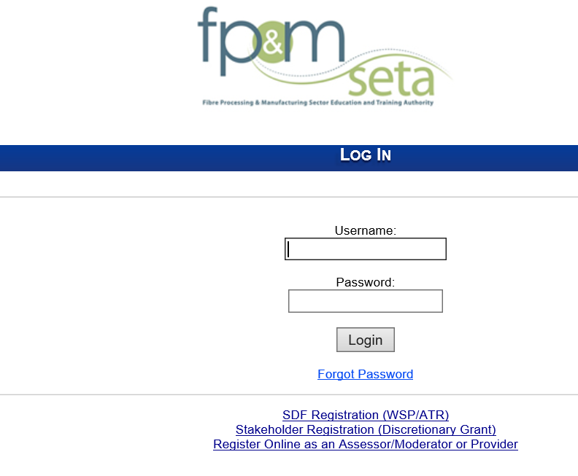

To reset password
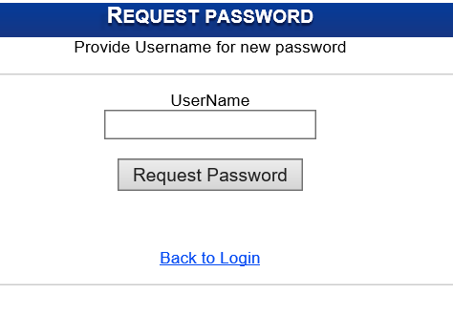

General

To change the layout of you Sub-menus click on the Arrow on the far-right on the system screen.

Learner
The following steps needs to be followed to create a new Learner on Indicium:
Step | Action | Screenshot
1. | Login into the system | 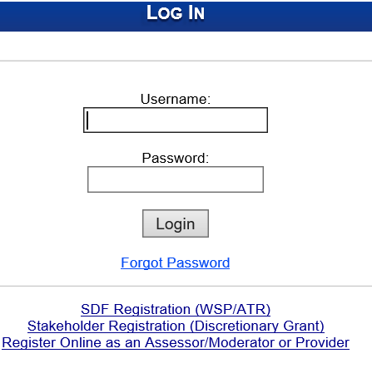
2. | Click on the ETQA menu item
3. | Click on Learner from the ETQA Menu | 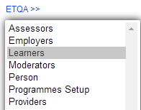

Capturing Learner Details

This section allows users to search and add new learners .

Step |  | Action | Screenshot
1. | Click ETQA in the Main Menu
2. | Click on Person from the ETQA Menu |  | 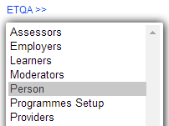
3. | Click on the Create New button
4. | Capture the persons details |  | 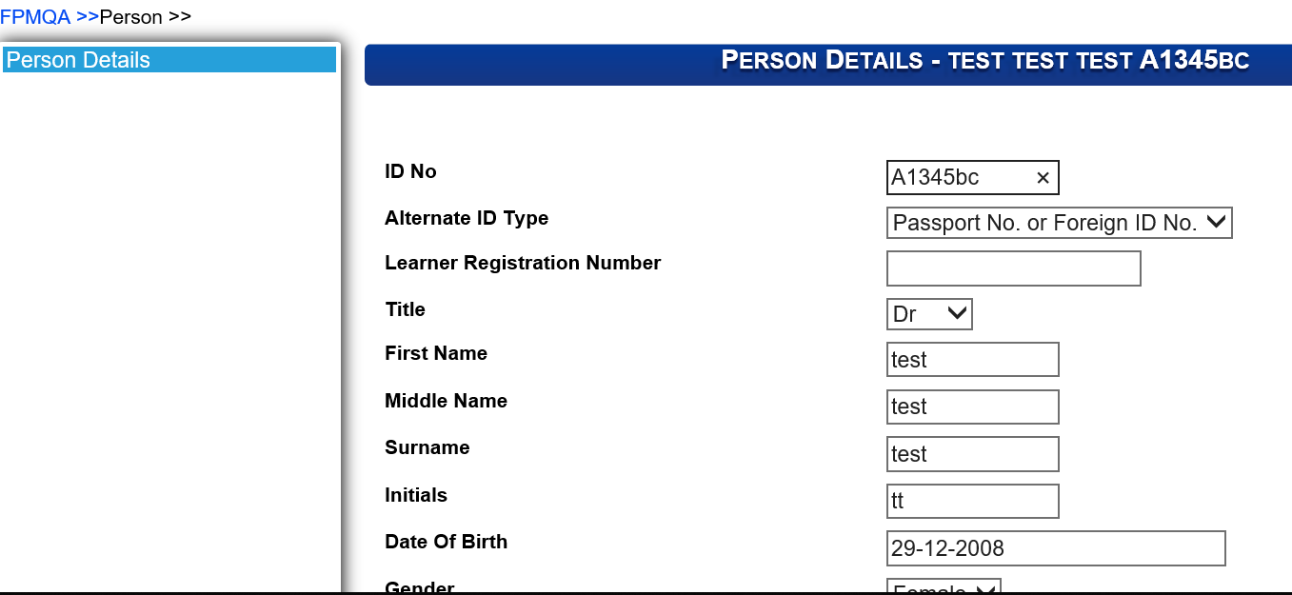
5. | Click on the Save button to save the information captured
6. | Click on Learners on the ETQA Menu |  | 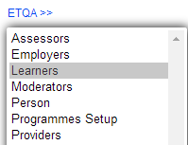
7. | Click on the Create New button
8. | Add search criteria and click on search |  | 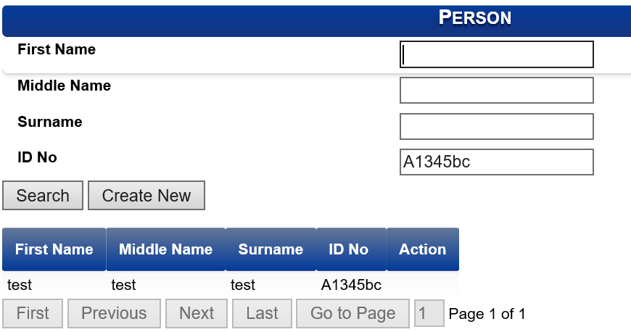
9. | Person records that meet the criteria will display. Click on the record and select Create |  | 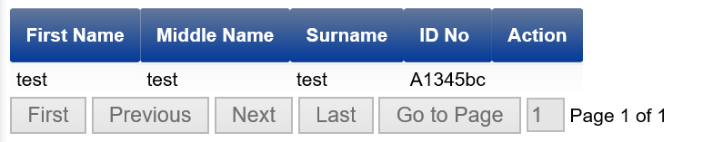
11. | To search for a learner record, add search criteria and search. The records will come up, select the record |  | 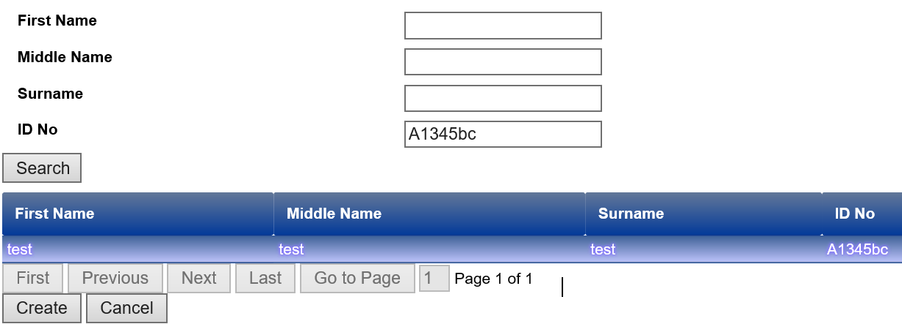

Registration of Programmes against Learners

The section below outlines the process for Registering of Programmes against a learner

Step |  | Action | Screenshot
1. | Click ETQA in the Main Menu
2. | Click on Learners rom the ETQA Menu
3. | Add Search criteria to search for the person details
4. | Select the Learner that needs to be registered .The row will be highlighted when selected
5. | Click on the magnifying glass icon to open |  | 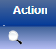
6. | The system opens the Learner Menu |  | 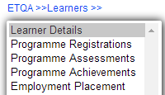
7. | Click on Programme Registrations |  | 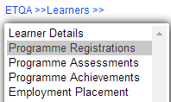
8. | Programme Registrations: This allows the user to capture Learning Programmes against a learner. |  | 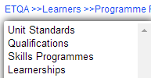

Programme Registrations: Unit Standards

This section allows users to change data added.

Step |  | Action | Screenshot
1. | Within the Learner details under the Programme Registration tab Click Unit Standards |  | 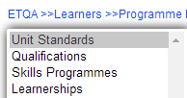
2. | Click on Add Unit Standard
3. | Add Search criteria to search for the provider, unit standard and employer details. Add all the detail related to the linking |  | 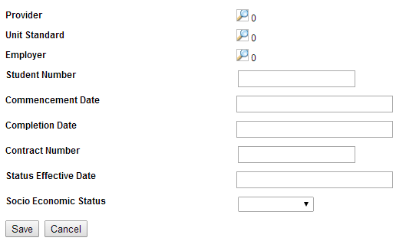
4. | Click on Save or cancel
5. | When wanting to update, click on the record to highlight it |  | 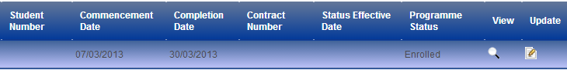
6. | Click on View to see the information or Edit to change details

Programme Registrations: Qualification

This section allows users to register learners.

Step |  | Action | Screenshot
1. | Within the Learner details under the Programme Registration tab Click Qualification |  | 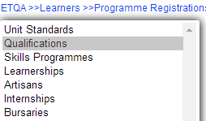
2. | Click on Qualification
3. | Add Search criteria to search for the provider, unit standard and employer details. Add all the detail related to the linking |  | 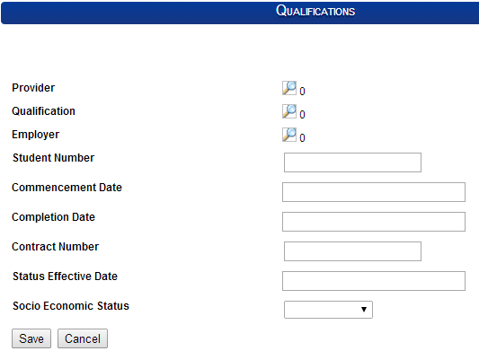
4. | Click on Save or cancel
5. | When wanting to update, click on the record to highlight it
6. | Click on View to see the information or Edit to change details

Programme Registrations: Skills Programme
This section allows users to register learners.

Step |  | Action | Screenshot
1. | Within the Learner details under the Programme Registration tab Click Skills Programmes |  | 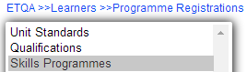
2. | Click on Add Skills Programmes
3. | Add Search criteria to search for the provider, unit standard and employer details. Add all the detail related to the linking |  | 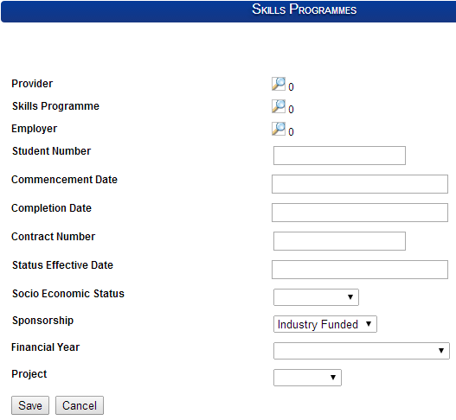
4. | Click on Save or cancel
5. | When wanting to update, click on the record to highlight it
6. | Click on View to see the information or Edit to change details

Programme Registrations: Learnerships

This section allows users to register learners

Step |  | Action | Screenshot
1. | Within the Learner details under the Programme Registration tab Click Learnerships |  | 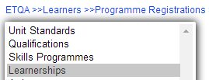
2. | Click on Add Learnerships
3. | Add Search criteria to search for the provider, unit standard and employer details. Add all the detail related to the linking |  | 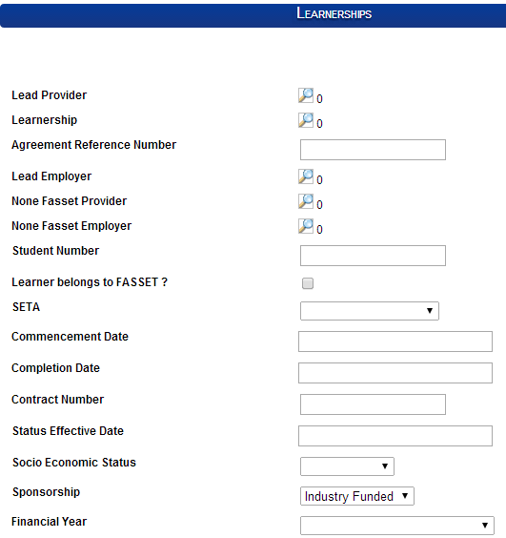
4. | Click on Save or cancel
5. | When wanting to update, click on the record to highlight it
6. | Click on View to see the information or Edit to change details

Programme Registrations: AET

This section allows users to register learners to AET
Step |  | Action | Screenshot
1. | Within the Learner details under the Programme Registration tab Click AET |  | 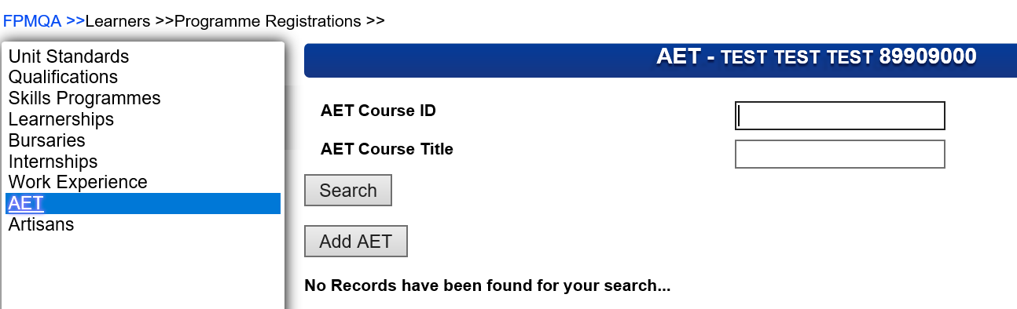
2. | Click on Add AET
3 | Add Search criteria to search for the provider, unit standard and employer details. Add all the detail related to the linking |  | 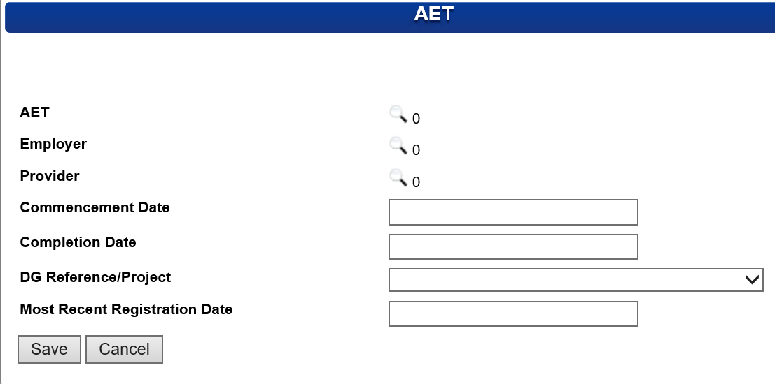
4. | Click on Save or cancel
5. | When wanting to update, click on the record to highlight it |  | 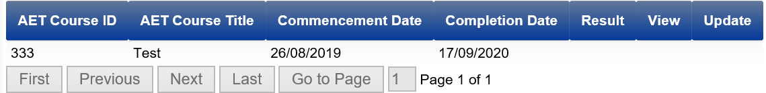
6. | Click on View to see the information or Edit to change details

Programme Registrations:Bursary

This section allows users to register learners.
Step |  | Action | Screenshot
1. | Within the Learner details under theProgramme Registration tab Click Bursary |  | 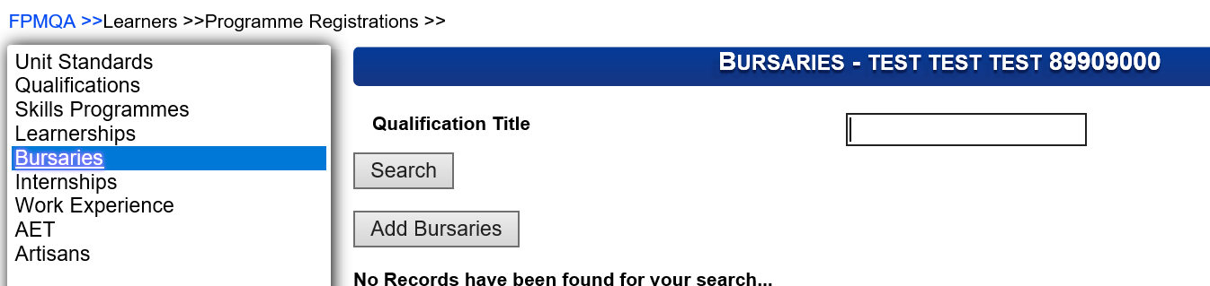
2. | Click on Add Bursary
3 | Add Search criteria to search for the Employer , Financial Year and all the detail related to the linking |  | 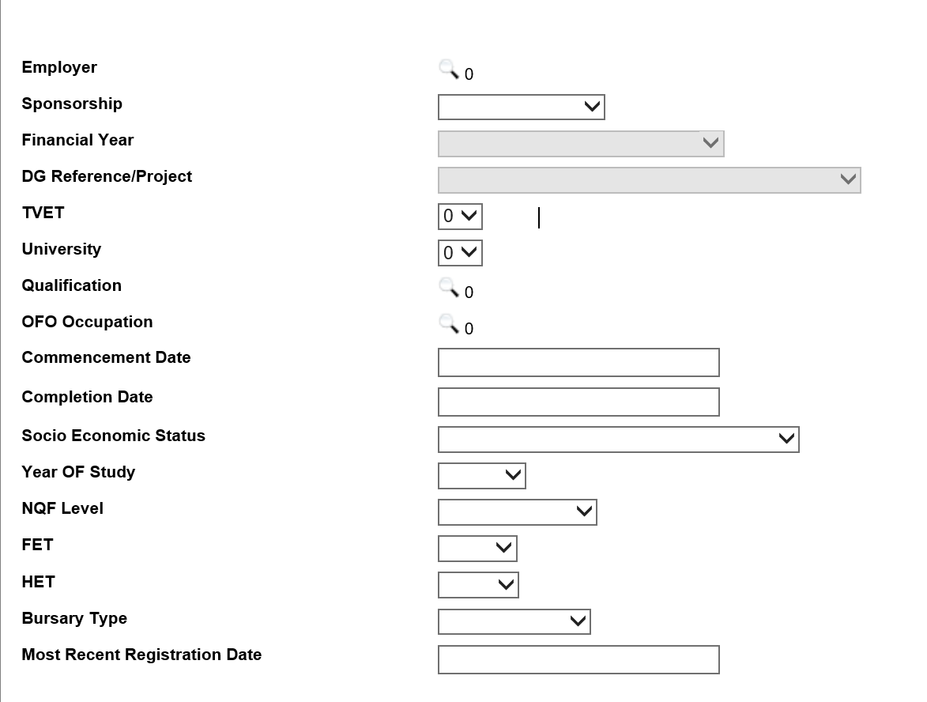
4. | Click on Save or cancel
5. | When wanting to update, click on the record to highlight it
6. | Click on View to see the information or Edit to change details

Programme Registrations:Internship

This section allows users to register learners against internship
Step |  | Action | Screenshot
1. | Within the Learner details under theProgramme Registration tab Click Internship |  | 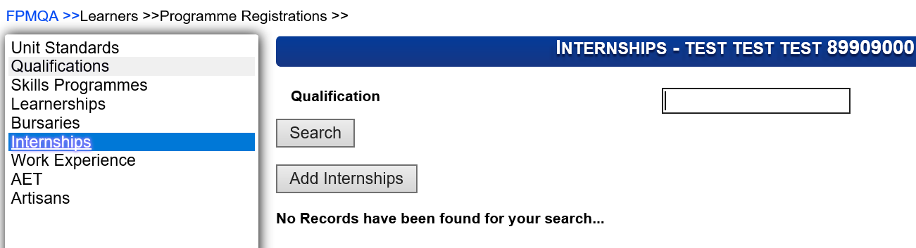
2. | Click on Add Internship
3 | Add Search criteria to search for the Employer , Financial Year and all the detail related to the linking |  | 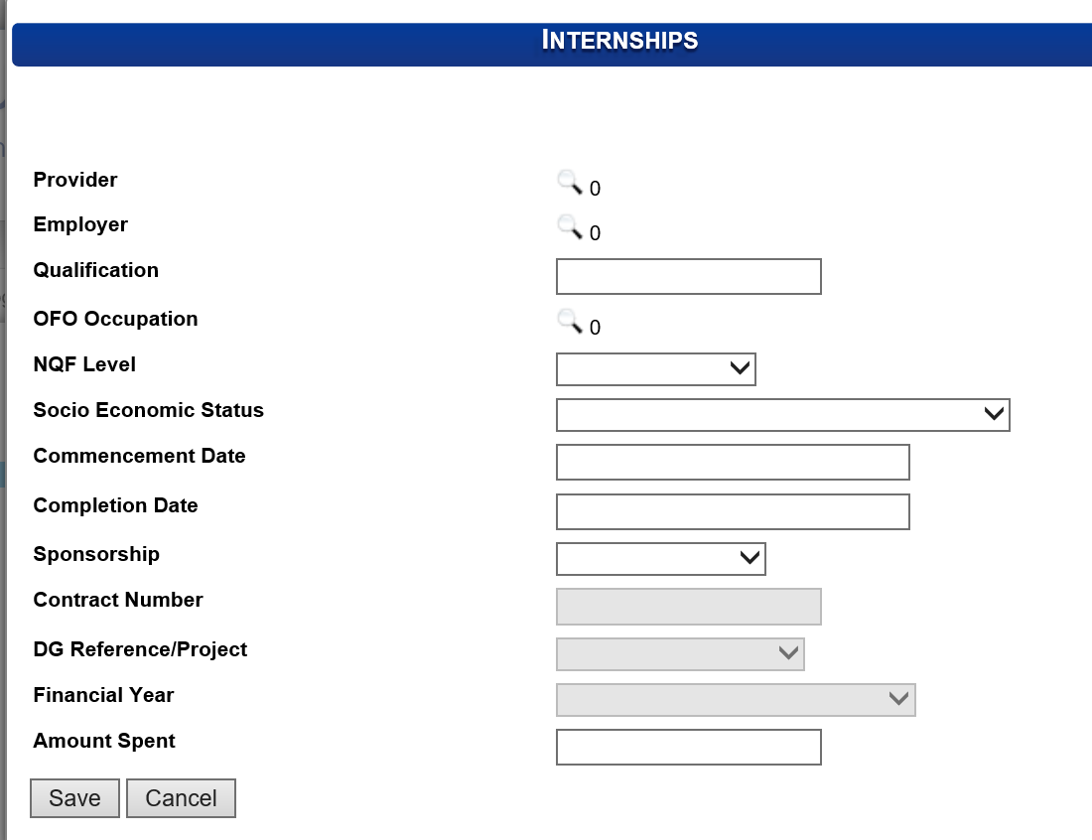
4. | Click on Save or cancel
5. | When wanting to update, click on the record to highlight it |  | 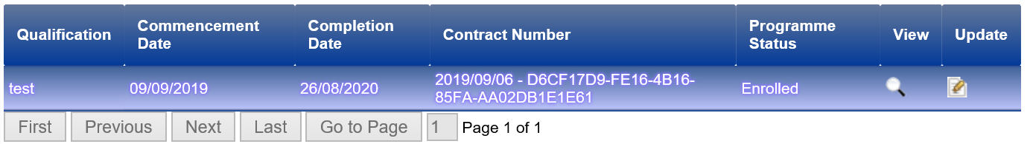
6. | Click on View to see the information or Edit to change details

Programme Registrations:Work Experience
This section allows users to register learners against Work experience
Step |  | Action | Screenshot
1. | Within the Learner details under theProgramme Registration tab Click Work Experience |  | 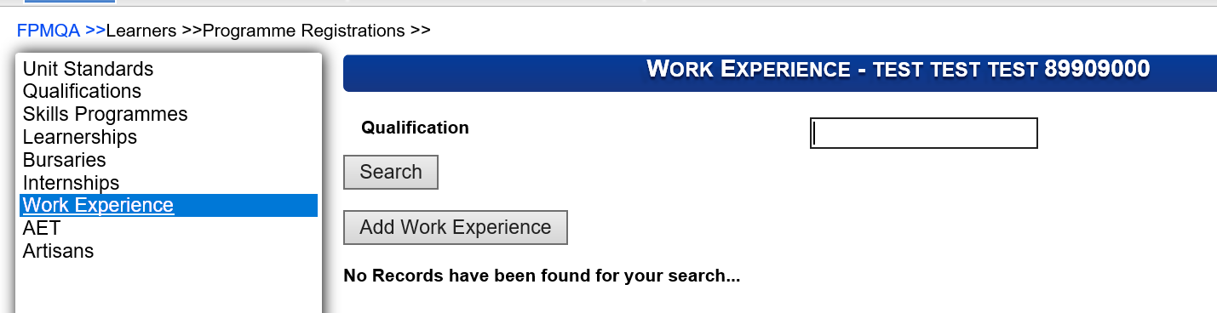
2. | Click on Add Work Experince
3 | Add Search criteria to search for the Employer , Financial Year and all the detail related to the linking |  | 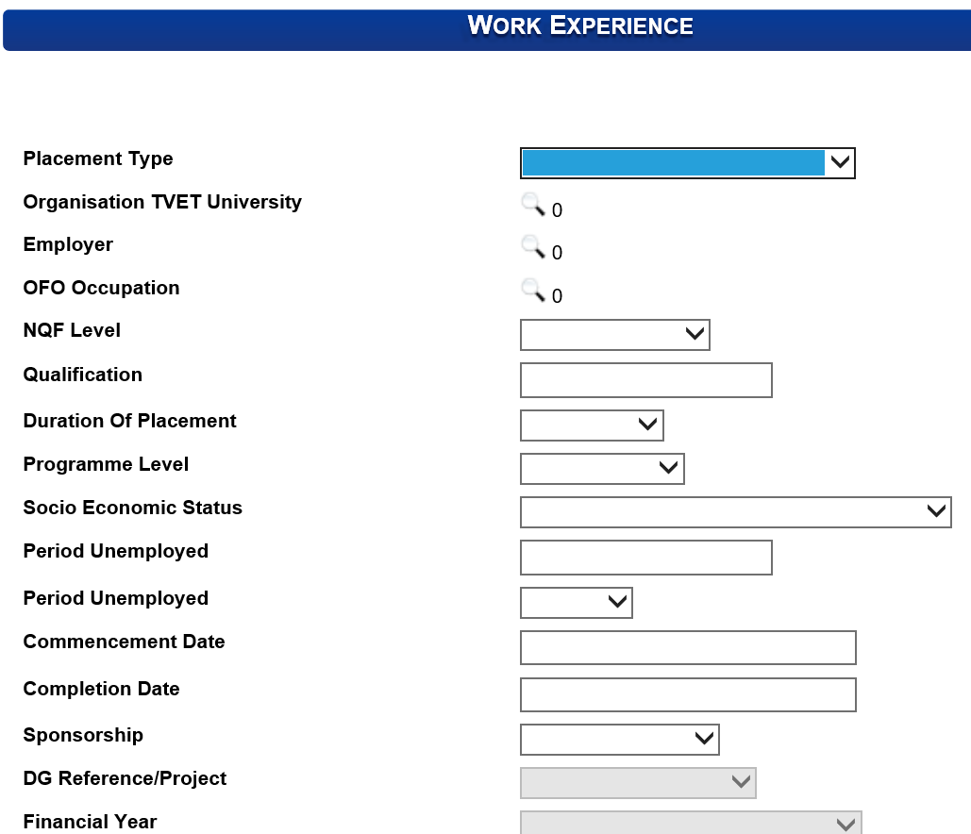
4. | Click on Save or cancel
5. | When wanting to update, click on the record to highlight it
6. | Click on View to see the information or Edit to change details

Programmes Assessments against Learners
Step |  | Action | Screenshot
1. | Click ETQA in the Main Menu
2. | Click on Learners rom the ETQA Menu
3. | Add Search criteria to search for the person details |  | 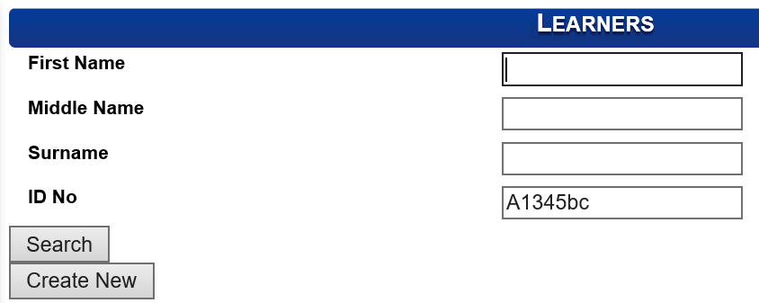
4. | Select the Learner that needs to be registered .The row will be highlighted when selected |  | 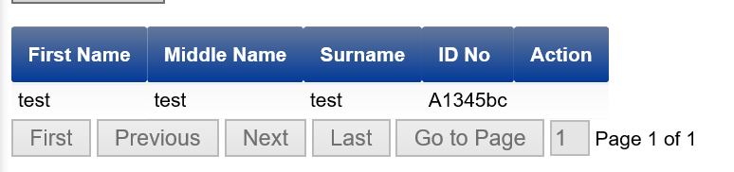
5. | Click on the magnifying glass icon to open
6. | The system opens the Learner Menu |  | 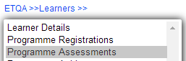
7. | Click on Programme Assessments
8. | Programme Assessments: This allows the user to Assess Learning Programmes against a learner.

Programme Assessments: Unit Standards

Step | Action | Screenshot
1. | Within the Learner details under the Programme Registration tab Click Unit Standards | 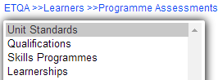
2. | Select the line item to upload assessments
3. | Click on View to see assessments uploaded
4. | Click on Update to capture or edit any assessments
5. | Search for an Assessor/moderator/verifier using the magnifying glass icon | 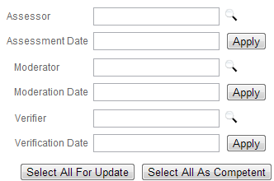
6. | Search for an assessor/moderator/ verifier, highlight the record | 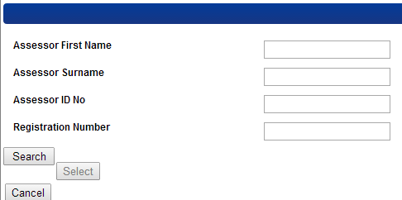
7. | Click on Select | 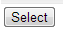
8. | Select which unit standards to be updated and which should be marked as competent. OR the unit standards can be marked individually with the tick boxes | 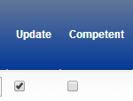
9. | Click on Update Assessments to save the assessments
10. | Click on the red cross next to a unit standards to remove assessments

Programme Assessments: Qualifications
Step | Action | Screenshot
1. | Within the Learner details under the Programme Registration tab Click Qualifications | 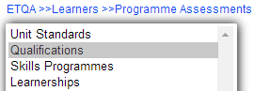
2. | Select the line item to upload assessments | 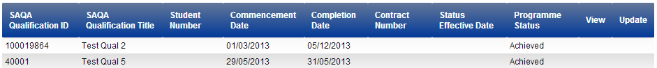
3. | Click on View to see assessments uploaded
4. | Click on Update to capture or edit any assessments
5. | Search for an Assessor/moderator/verifier using the magnifying glass icon
6. | Search for an assessor/moderator/ verifier, highlight the record
7. | Click on Select
8. | Select which unit standards to be updated and which should be marked as competent. OR the unit standards can be marked individually with the tick boxes
9. | Click on Update Assessments to save the assessments
10. | Click on the red cross next to a unit standards to remove assessments

Programme Assessments: Skills Programme

Step | Action | Screenshot
1. | Within the Learner details under the Programme Registration tab Click Skills Programme | 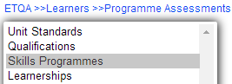
2. | Select the line item to upload assessments | 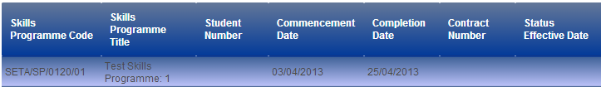
3. | Click on View to see assessments uploaded
4. | Click on Update to capture or edit any assessments
5. | Search for an Assessor/moderator/verifier using the magnifying glass icon
6. | Search for an assessor/moderator/ verifier, highlight the record
7. | Click on Select
8. | Select which unit standards to be updated and which should be marked as competent. OR the unit standards can be marked individually with the tick boxes
9. | Click on Update Assessments to save the assessments
10. | Click on the red cross next to a unit standards to remove assessments

Programme Assessments: Learnerships

Step | Action | Screenshot
1. | Within the Learner details under the Programme Registration tab Click Learnerships | 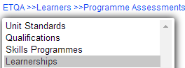
2. | Select the line item to upload assessments
3. | Click on View to see assessments uploaded
4. | Click on Update to capture or edit any assessments
5. | Search for an Assessor/moderator/verifier using the magnifying glass icon
6. | Search for an assessor/moderator/ verifier, highlight the record
7. | Click on Select
8. | Select which unit standards to be updated and which should be marked as competent. OR the unit standards can be marked individually with the tick boxes
9. | Click on Update Assessments to save the assessments
10. | Click on the red cross next to a unit standards to remove assessments

Programmes Achievements against Learners
The section below outlines the Programmes achieved against a Learner once they have been QA Approved and marked as achieved.

Step |  | Action | Screenshot
1. | Click ETQA in the Main Menu
2. | Click on Learners rom the ETQA Menu
3. | Add Search criteria to search for the person details
4. | Select the Learner that needs to be registered .The row will be highlighted when selected
5. | Click on the magnifying glass icon to open
6. | The system opens the Learner Menu
7. | Click on Programme Assessments
8. | Programme Assessments: This allows the user to Assess Learning Programmes against a learner.
9. | Open programme and click on ETQA Approve Assessments |  | 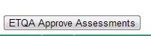
10. | The programme will move from assessments to the Achievements tab |  | 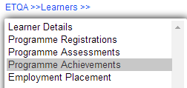
11. | Programme Achievements: This allows the user to view Learning Programme Assessments against a learner
12. | Achievements can be viewed from this tab |  | 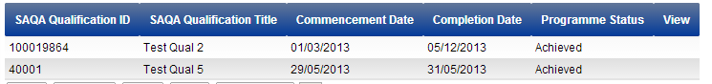

Employment Placement
This section will assist the QA to monitor the workplace placement of Learners. The section will display the following

Step |  | Action | Screenshot
1. | Click ETQA in the Main Menu
2. | Click on Learners rom the ETQA Menu
3. | Add Search criteria to search for the person details
4. | Select the Learner that needs to be registered .The row will be highlighted when selected
5. | Click on the magnifying glass icon to open
6. | The system opens the Learner Menu |  | 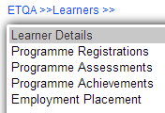
7. | Click on Employment Placement |  | 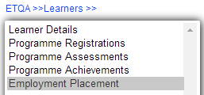
8. | Capture the detail for the Learner |  | 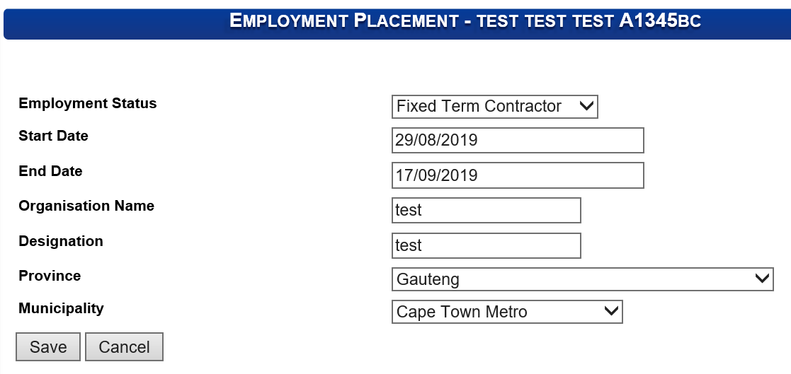

Learners supporting Document

The section below outlines the process for Learner Supporting Document

Step |  | Action | Screenshot
1. | Click ETQA in the Main Menu
2. | Click on Learners rom the ETQA Menu
3. | Add Search criteria to search for the person details
4. | Select the Learner that needs to be registered .The row will be highlighted when selected
5. | Click on the magnifying glass icon to open
6. | The system opens the Learner Menu
7. | Click on Learner Supporting Documents |  | 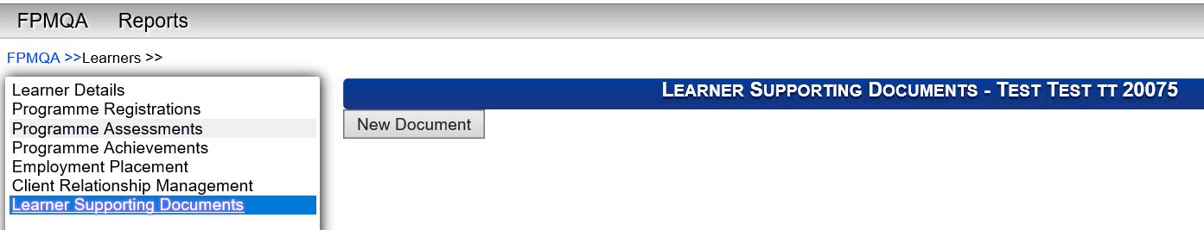
8. | Learner Supporting Documents : This allows the user to uploading supporting documnents . |  | 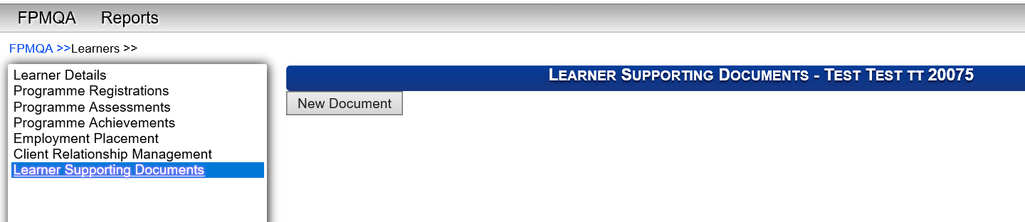
9. | Click on New Documnet |  | 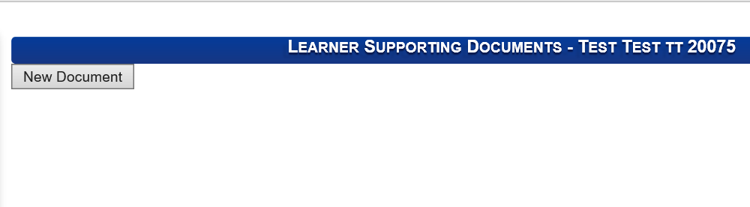
10. | Select the drop down with to select the document you want to upload |  | 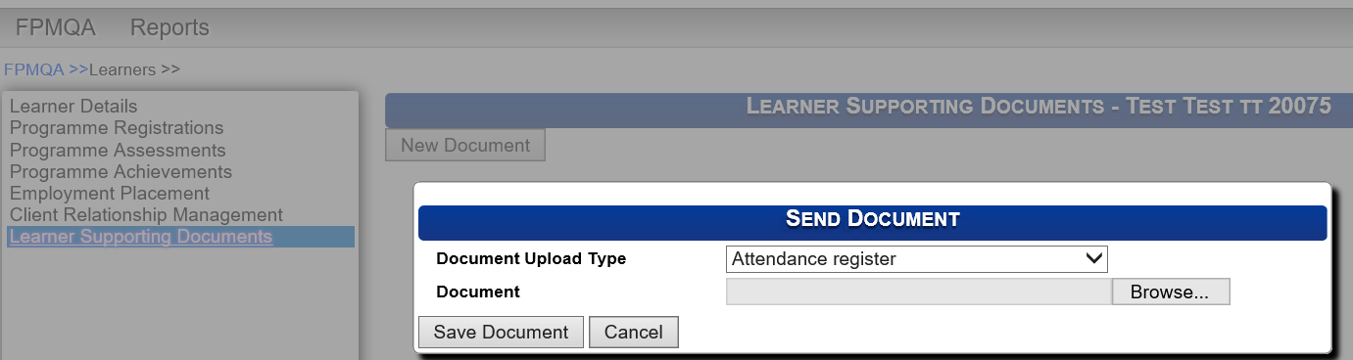
11. | Click on Borwse to upload documents  Then Click on Save

Additional Notes

