Organisation: | FP&M SETA
Project name: | DG system Stakeholder Manual
Date: | 13 February 2019

Table of Contents
1 Important information to Note before registering as Stakeholder: 2
2 SDF Profiles on the system 2
2.1 Document required 2
3 HOW TO REGISTER AS NEW STAKEHOLDER 2
4 ACCESSING ORGANISATION INFORMATION AND CREATING FORMS 4
5 UPLOADING SUPPORTING DOCUMENT 5
6 CAPTURING INFORMATION ON PIVOTAL FORMS 6
7 CAPTURING INFORMATION ON NON PIVOTAL FORMS 7
8 EDITING INFORMATION IN THE FORMS 8
9 SUBMITTING FORMS 9

Important information to Note before registering as Stakeholder:

- ID / alternative ID number are key during the registration process
- Scanned appointment letter from the Organization(s) to be on hand when accessing the system to register.
- Stakeholders to know the SDL numbers of their organization’s as they will be required to link and search using the SDL number on the system
- None levy paying organizations will have N number allocated to them by FPMSETA

SDF Profiles on the system
- Stakeholder Capturer which includes all approved stakeholders including SSAs)
- Stakeholder (view only)

Document required
•Valid Tax Clearance Certificate/Tax Exemption document
•CIPRO/Government Registration
•BEE Certificate (if applicable) Bee Level must be selected before you Submit
•Bargaining Council certificate/exemption letter
•Proof of accreditation
•Letter/agreement appointing external training provider
•Occupation Health and Safety Certificate (If applicable)

HOW TO REGISTER AS NEW STAKEHOLDER
Steps |  | Action | Screenshot
1 |  | Click on Register to register as Stakeholder in the system
2 |  | Click on Register from the Registration Menu | 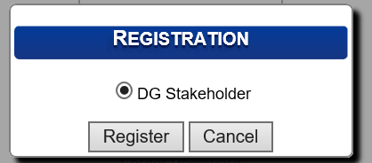
3 |  | Capture your personal details on the “Applicant Details” page. | 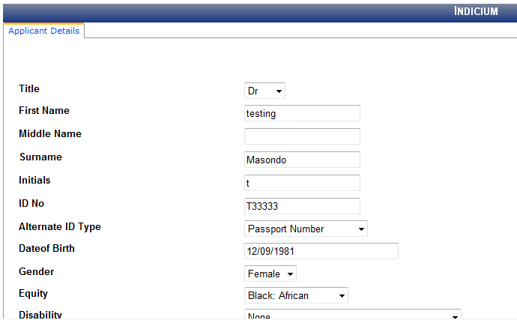
4 |  | Click on the Save and Proceed button to move to the next step.
5 |  | Click the magnifying glass to search for organisation SDL number | 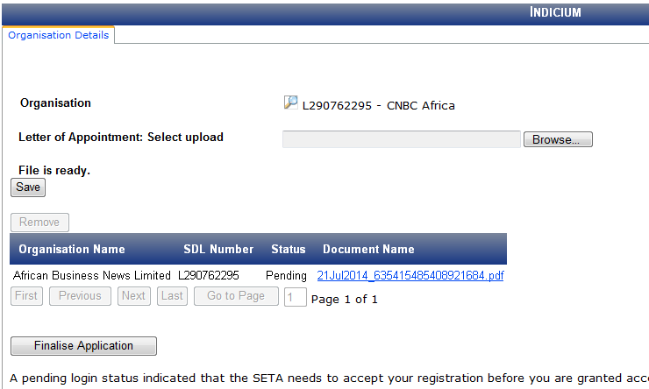

ACCESSING ORGANISATION INFORMATION AND CREATING FORMS

Steps | Action | Screenshot
1 | Login into the system | 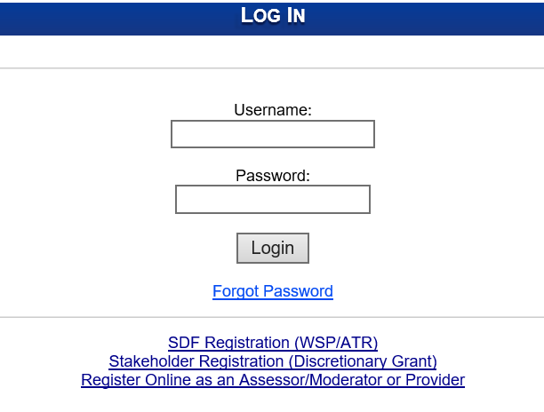
2 | The Stakeholder Dashboard will open  Click on organisation  Click on organisation and search for SDL number  Organisation will open at the bottom for Stakeholder to open  Click on the Magnifying glass to open | 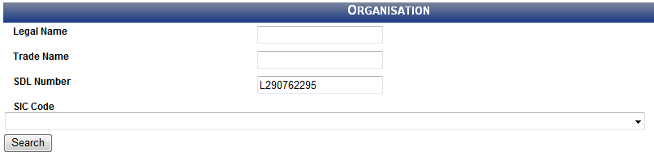  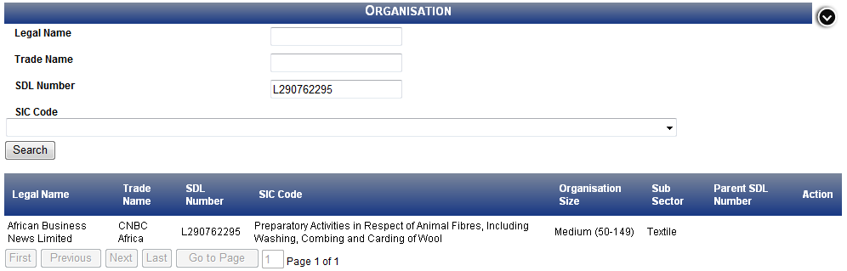  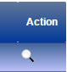
3 | Stakeholder must confirm organisation details  click the edit button and then confirm on the tick box  Then click on Save | 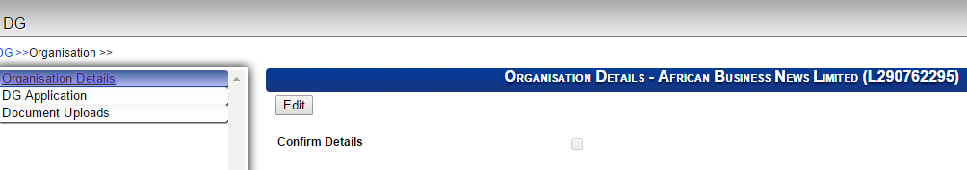  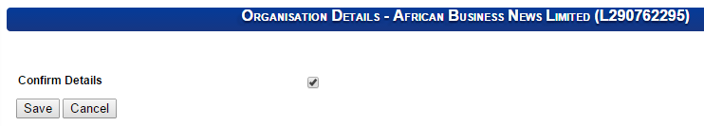

UPLOADING SUPPORTING DOCUMENT
The section below outlines the process for uploading supporting document
Steps | Action | Screenshot
1 | Click on document type then click on choose file  Capture details and save | 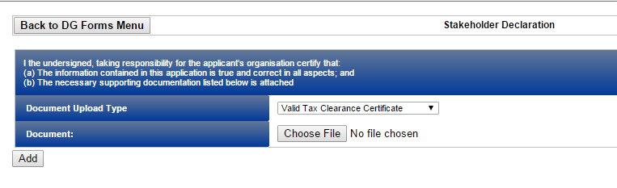  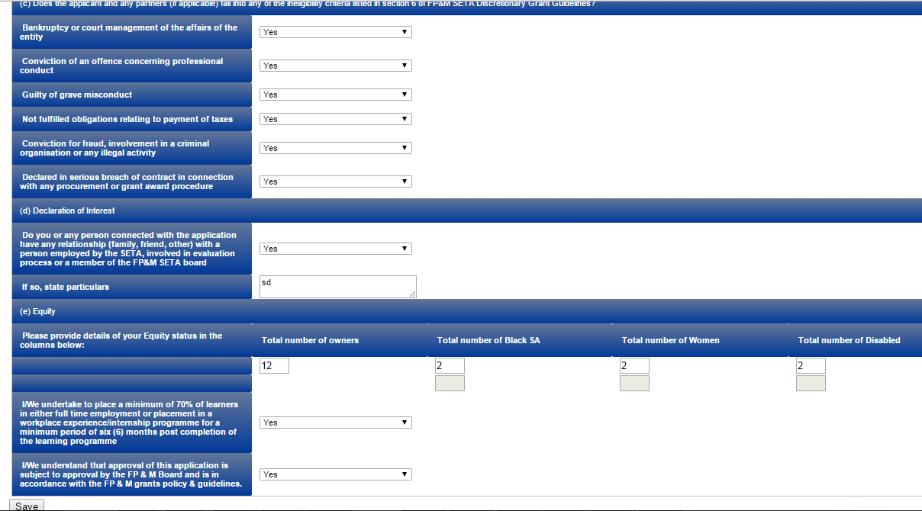
2 | File uploaded will show as below | 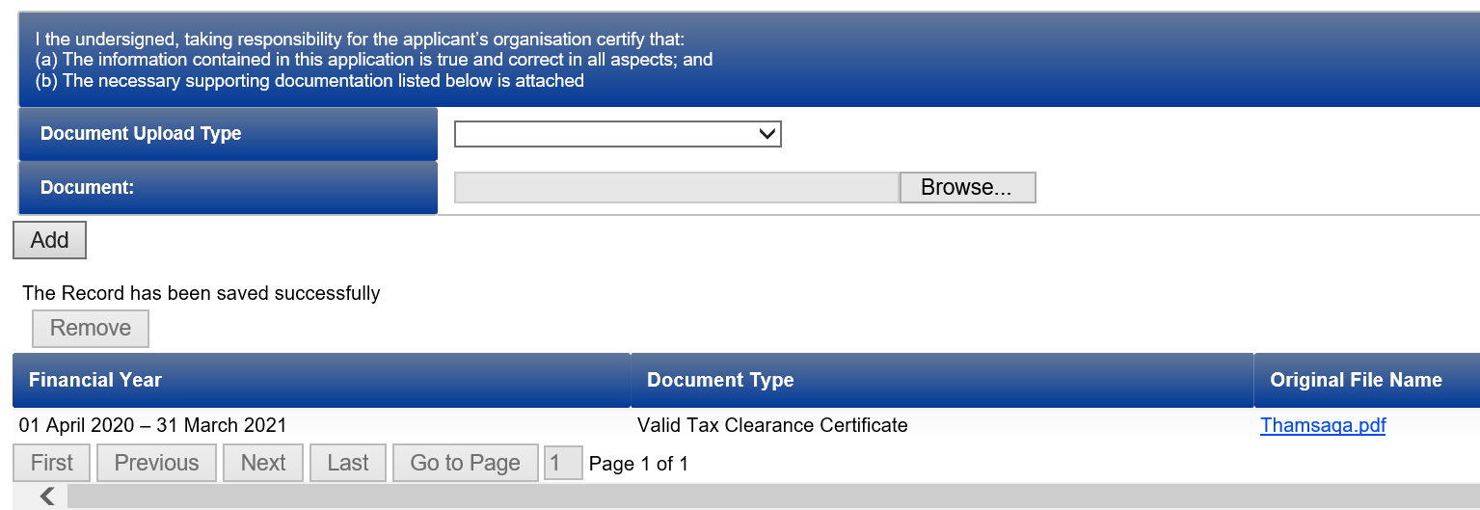

CAPTURING INFORMATION ON PIVOTAL FORMS
Steps | Action | Screenshot
1 | Click on Grant Type details then click on select button to open  Capture information and Save  Information captured will show as below | 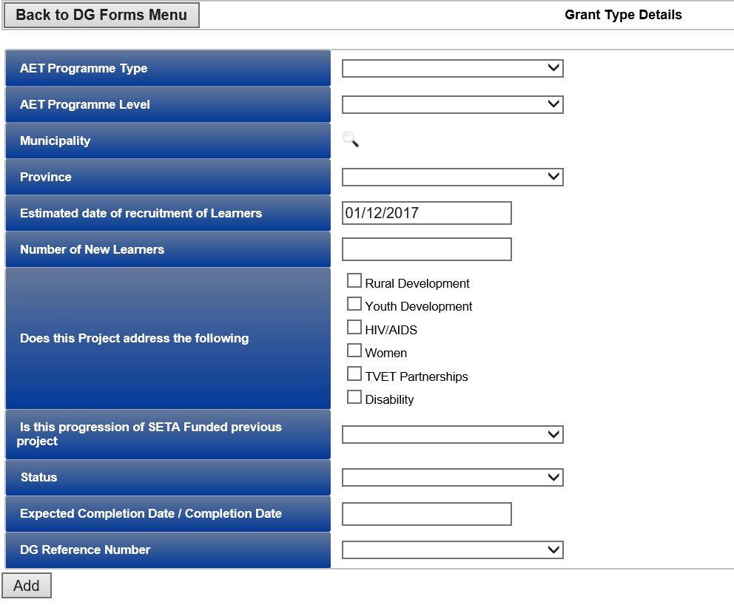  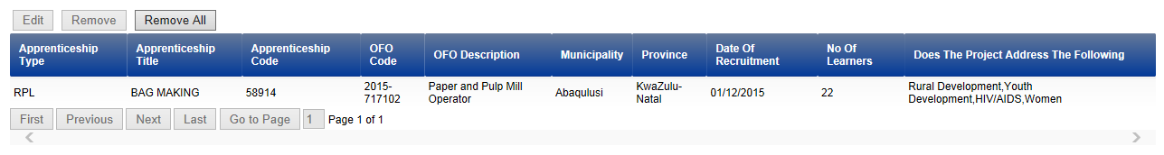

CAPTURING INFORMATION ON NON PIVOTAL FORMS

Steps | Action | Screenshot
1 | Click on Grant Type details then click on select button to open  Capture information and Click on add to Save  Information captured will show as below  Click on Project budget summary  Capture information and Save | 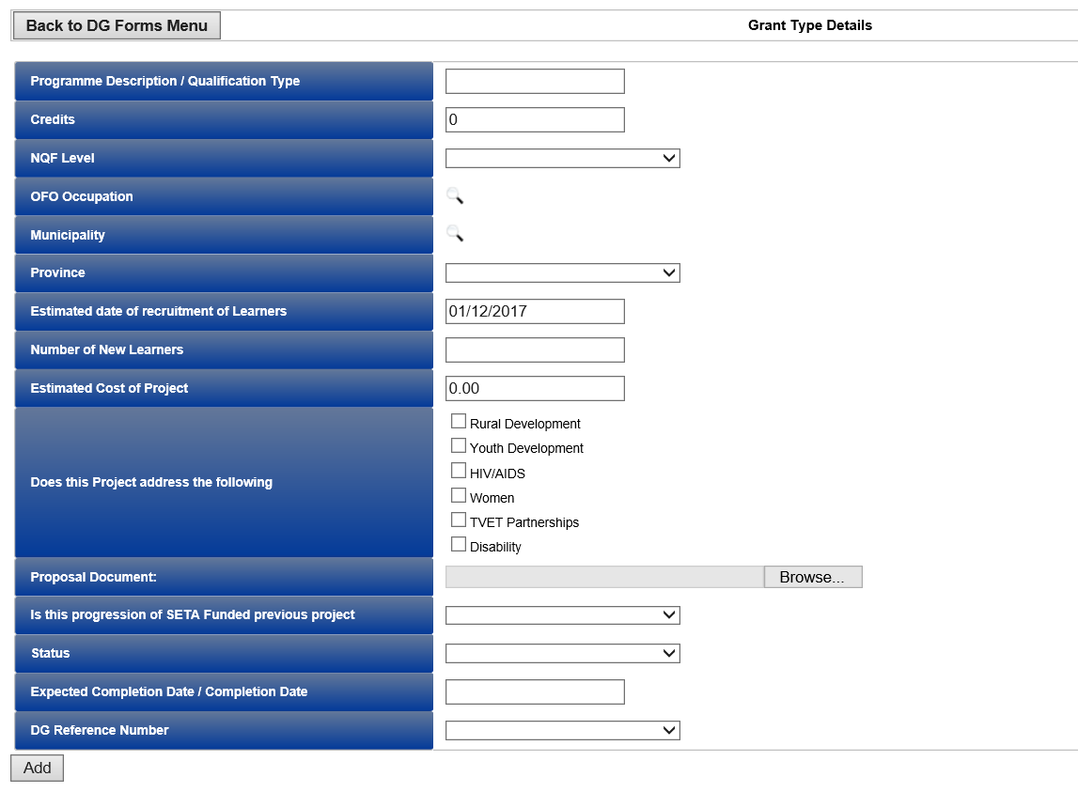  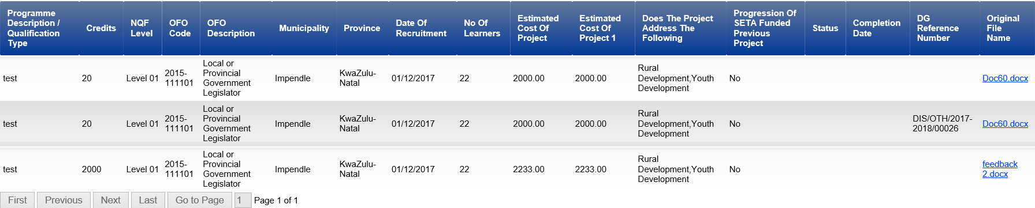  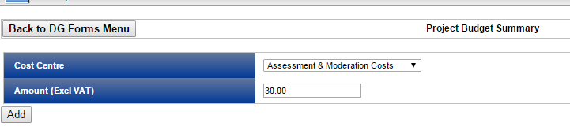

EDITING INFORMATION IN THE FORMS

Steps | Action | Screenshot
1 | Click on Grant Type details then click on select button to open  Click on the information you want to Edit and click on button to edit  Info will open for Stakeholder to Edit and then click on update to update | 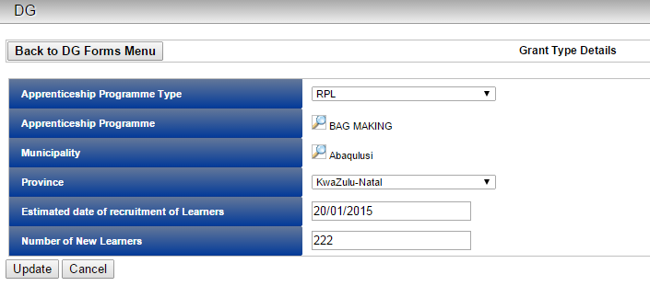

SUBMITTING FORMS

Welcome to the 2020/2021 funding window.
Before you proceed, please ensure that you have a minimum of the following documents for upload purposes in electronic format on hand to be able to proceed with the application:
• Valid Tax Clearance Certificate/Tax Exemption document
• CIPRO/Government Registration
• BEE Certificate
• Bargaining Council certificate/exemption letter
• Proof of accreditation
• Letter/agreement appointing external training provider
• Occupation Health and Safety Certificate (If applicable)
Steps | Action | Screenshot
1 | Click forms you want to Submit  Then click on View to open  Click on Submit DG application  Click ok to submit  DG Status will show as Submitted | 